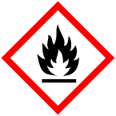
Emory University, Environmental Health and Safety Office Can be printed on Avery 5160 or compatible labels.
GHS Pictogram Label Template – All Symbols_1

